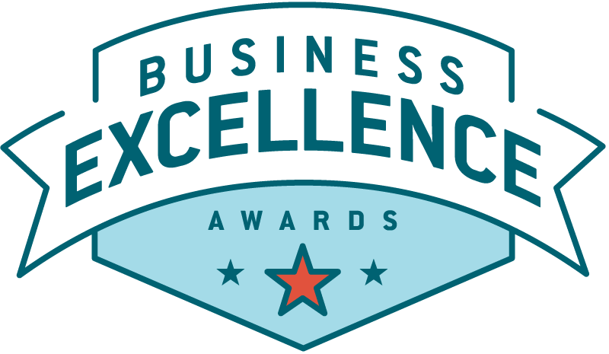

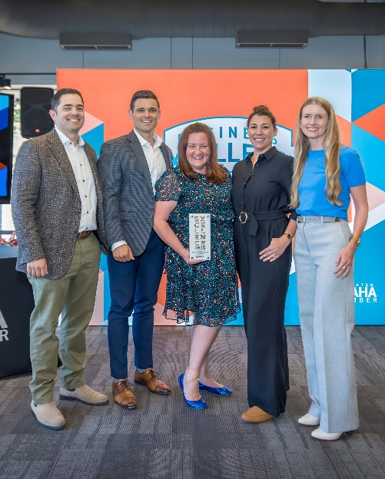
Celebrating Excellence in Omaha.

Excellence is a way of life here – earned not given – and it should be celebrated! Each year, the Chamber selects Business Excellence Award recipients from nominations gathered from the community.
These awards are our way of celebrating the incredible amount of excellence around us and awarding the truly deserving – those whose contributions elevate our community and make it a better place for everyone to do business, work and live.

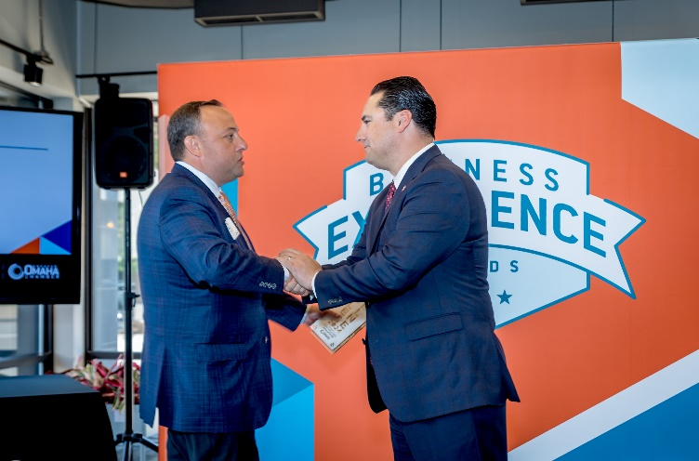
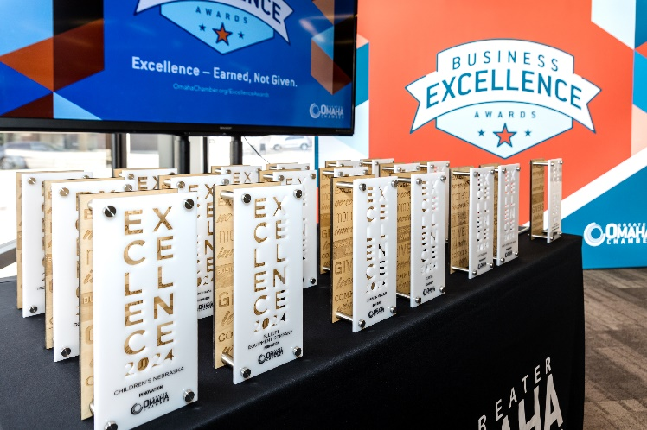

EVENT DETAILS:

Thursday June 4th, 2026
All Makes
2558 Farnam St, Omaha, NE 68131

Pre- Reception | 4:30 PM
Program | 5 PM
Reception | 5:30 PM

SPONSORSHIP CONTACTS
Chamber Events Team events@OmahaChamber.org

2026 SPONSORSHIP OPPORTUNITIES

Celebrate excellence and elevate your brand at the Chamber’s annual business recognition event. The Business Excellence Awards honor outstanding companies and leaders whose innovation, service, and impact strengthen our business community. Below are sponsorship opportunities designed to maximize your organization’s visibility and engagement.

As a sponsor, your business will connect with a diverse audience of community and business leaders while gaining broad exposure across the Chamber’s membership through strategic pre-event, on-site, and post-event marketing.

____ PRESENTING SPONSOR: SOLD OUT

____ SUPPORTING SPONSOR: $5,000

Benefits include:
- 10 Tickets in priority seating
- Opportunity to present awards
- Listed on the Event Website & Registration Landing Page
- Recognized at Event (Visual and Verbal Recognition)
- Provided a Sponsor Toolkit

____ CORPORATE SPONSOR: $1,000

Benefits include:
- 10 Tickets in reserved seating*
- Listed on the Event Website & Registration Landing Page
- Recognized at Event (Visual and Verbal Recognition)
- Provided a Sponsor Toolkit

2026 BUSINESS EXCELLENCE AWARDS
SPONSORSHIP FORM

Upon agreeing to sponsor the Business Excellence Awards, return this form to events@OmahaChamber.org

- If your sponsorship offers a logo opportunity, please provide your brand guidelines & high-res company logos in black, white and full color in vector file format (.ai) as well as in a .png and .jpg (6 logos total)

Sponsorship Level:

Company Name:
As it should appear on all marketing materials.
Sponsorship Representative:
Main contact for sponsorship.
Mailing Address:
(City, State, Zip Code)
Sponsor Representative Email Address:
Sponsor Representative Phone Number:
Company Website:
To link on our event webpage.

Total Amount to be Invoiced: | $

Signed Sponsor Representative Date

Greater Omaha Chamber Representative Date

